# Reigning Champions by Gender

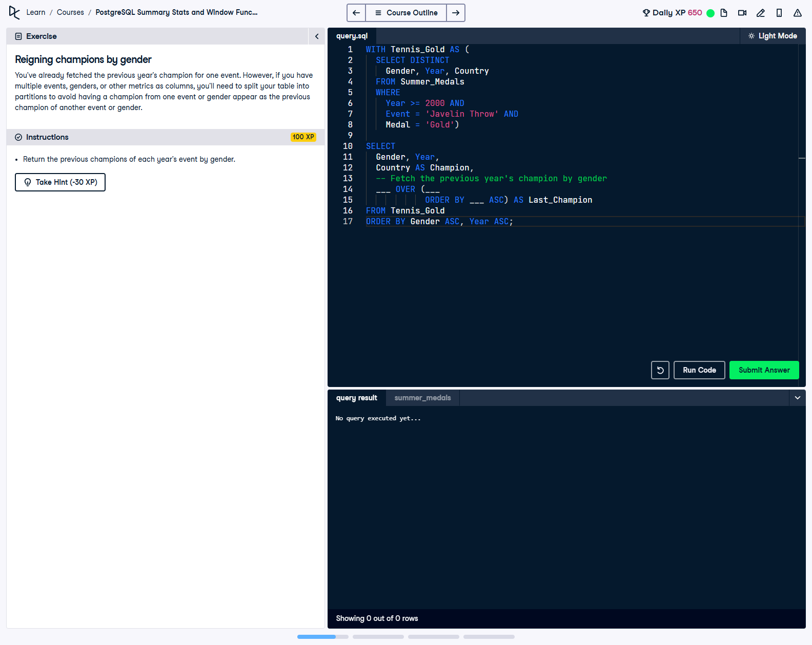

You’ve already fetched the previous year’s champion for one event. However, if you have multiple events, genders, or other metrics as columns, you’ll need to split your table into partitions to avoid having a champion from one event or gender appear as the previous champion of another event or gender.

This exercise involves using a Common Table Expression (CTE) and the `LAG` function to find the reigning champions for each gender in the Javelin Throw event, ensuring comparisons are made only within the same gender group.

## Correct Answer

WITH Tennis_Gold AS (  
 SELECT DISTINCT  
 Gender, Year, Country  
 FROM Summer_Medals  
 WHERE   
 Year >= 2000 AND  
 Event = 'Javelin Throw' AND  
 Medal = 'Gold'  
)  
SELECT  
 Gender, Year,  
 Country AS Champion,  
 LAG(Country) OVER (PARTITION BY Gender ORDER BY Year ASC) AS Last_Champion  
FROM Tennis_Gold  
ORDER BY Gender ASC, Year ASC;

Explanation of the query:

1. `WITH Tennis_Gold AS (...)`: This CTE filters the dataset to include only gold medalists in the Javelin Throw event from the year 2000 onward. It selects unique combinations of gender, year, and champion country.

2. `LAG(Country) OVER (PARTITION BY Gender ORDER BY Year ASC) AS Last_Champion`: The `LAG` function fetches the champion country of the previous year within each gender group, allowing for comparisons between consecutive years.

3. `ORDER BY Gender ASC, Year ASC`: Sorts the final output by gender and year, ensuring a well-structured result.